Scoil Náisiúnta Cholmcille Naofa
Castlegar National School
School Rd.,
Castlegar, Galway

Tel:091-757362
E-mail: castlegarns@gmail.com
Website: www.castlegarns.ie

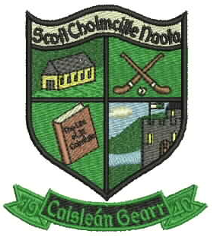
Dear Parents/Guardians,

On behalf of the staff, I extend a very warm welcome to you and your child to Castlegar N.S. It is our aim that your child will be extremely happy in our school and will achieve his/her full potential by being happy, sociable and respectful in our school’s pleasant and stimulating learning environment. There is a strong sense of community and a high level of co-operation between staff, pupils, parents and visitors

We have a wonderful staff and you can be assured of our full co-operation and commitment at all times.

Should you have any query or concerns at any time please feel free to come and talk to us.

Le gach dea ghuí,
Caitriona McCormack
Acting Principal
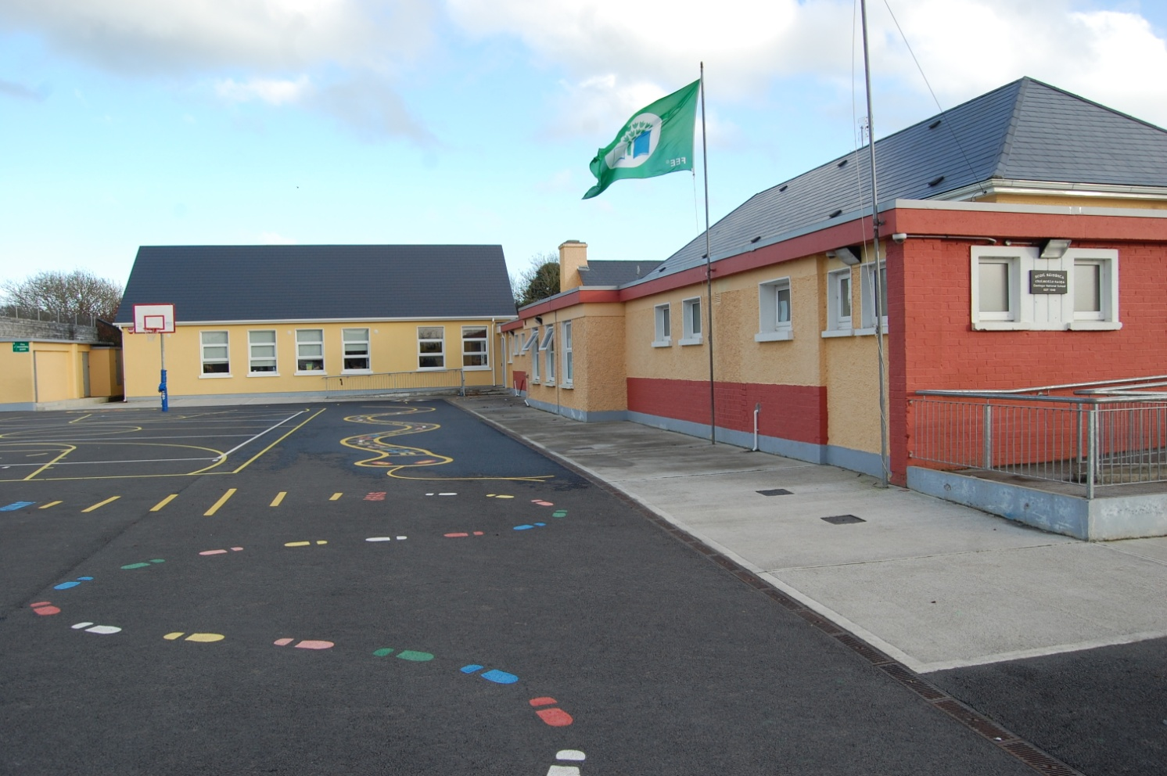
Staff:

The school has 10 teachers - four mainstream class teachers, one ASD class teacher, four SEN teachers and one Home School Community Liaison Teacher.
We also have five Special Needs Assistants (SNAs).
We are also very fortunate to have the services on a part-time basis of two ancillary staff members, secretary Marie Callaghan, and caretaker Eric Heneghan.

Role of the Home School Liaison Teacher:

The aim of the Home School Community Liaison (HSCL) is to promote partnership between home, school and the community and to ensure that every family participates fully in the school scheme. Castlegar NS recognises the role of parents as the primary educators of their children, the influence of the home environment and seeks to promote a partnership between school and parents and the local community. The HSCL teacher is available to discuss on a personal level, matters of concern with parents.
- Listen, encourage, support and offer suggestions on how parents can support their children.
- Offer free courses for parents.
- Offer one to one support to parents on how to get the best from their child’s learning.

Mission Statement:

Our school is a place where children are encouraged to grow and to develop in a supportive, positive and enjoyable atmosphere.
Our core aims are to provide a broad and comprehensive education, to recognise the needs and to develop the talents of each pupil. We are a caring school. We strive to live up to Christian values and to show genuine concern for one another.
We appreciate individuality and difference. We are committed to building a community, which respects the rights and uniqueness of each other.

Board of Management:

The school is run by the Board of Management. The B.O.M. has overall responsibility for the school, including finance, maintenance, staffing and the development of the school plan. The Board is made up of 8 people: 2 Parents nominees, 2 Community nominees, 2 members of the teaching staff (one of whom is the Principal) and 2 Patron’s/Diocesan nominees.
The Board of Management has a four-year term.

Our School’s Board of Management

Michael Canavan (Chairperson)
Fr Sean McHugh (Patron’s Nominee)
Caitriona McCormack (Principal/Secretary)
Ann Marie McPhilbin (Parent)
Stanislav Hresko (Parent)
Helena Gaughan (Teacher)
Michael Broderick (Community)
Deirdre Tully-Ruiz (Community)
Parent’s Association:

As a parent/guardian you are an automatic member of our Parents Association. The staff of the school is fortunate to have a very active, co-operative and supportive Parents’ Association. We appreciate that it is a voluntary body and we look forward to developing the school further with the continued help & support of the Association. The members of the Parents’ Association contribute to the formulation of all school policy documents in their capacity as partners in education.
The role of the Parents’ Association is to represent the views of the parents through their parental representatives on the Board of Management.
We encourage you to take an active part in our Parents Association. Your ideas and support will be crucial in helping to make the Parents Association a success. From time to time during the year the Parents Association run meetings, events and fund raisers. These contribute greatly to the social life of the school. They are also a means of getting to know new people while at the same time of making a real contribution to your child’s education.

Fund Raisers: We have fund raising drives in order that we may provide your child with the truly “all round” education we see as crucial to developing his/her potential, i.e. school dance, jumble sales, table quizzes, bag-packing etc. We depend on your generosity and support to make these fundraisers a success.

Remember –You are the Association so please do get involved! -

The School Day:

Junior & Senior Infants: 08.50 - 1.30pm
1st to 6th Class: 08.50 - 2.30pm
Morning Break: 10.50 - 11.00am
Lunch Break: 12.30 - 1pm
(certain times may be subject to change for 2020/2021 school year)

Punctuality and Attendance:

The children are expected to be punctual and to attend school every day. All children are expected to be in class for 8.50am. Late arrivals are not only disruptive to teaching but also to children’s’ learning as the core subjects (English, Irish and Maths) are generally scheduled in the morning. We ask parents to be punctual in the morning and again when collecting their children in the afternoon at 1.30pm and 2.30pm.

Children remain the responsibility of their parents/guardians before 8:50am. The B.O.M. would like to remind you that it does not provide for supervision outside of school hours. We thank you for your co-operation with this matter.

Dropping and Collecting Children to and from school:

Please see our COVID-19 response plan for dropping off and collection procedures.

Traffic and Parking:

Parking spaces are limited outside the school, we ask all parents to park responsibly and carefully:
- When you are dropping off your child, please do so in the drop off area (not on the main road) and exit as quickly as possible to allow for other parents drop off safely.
- When you are picking up your child/children please do so from the drop off area. If the drop off area is full, please form a queue on the road to gain entry to the roundabout, rather than parking up on the road exiting onto the main road. This means children will not have to walk down towards the main road and is a much safer option for all involved.
- On wet mornings, the new front door will be left open from 8:40am for the children to enter, they do not go to the yard but rather come straight into the school and make their way to their classroom.
- In the interest of Health and Safety please remind your children to take care while walking or cycling to school on the busy road outside our school. The Safe Cross Code should be followed by the children at all times.
- Please familiarise yourself with our parking guidelines on our school website www.castlegarns.ie

Early Home Going:

A note is necessary if a child has to leave the school during the day. No child will be released without this. We do this solely in the interest of each child’s safety. A child who has to leave early should be collected either at the office with Marie or in the classroom sign the ‘Sign Out’ book in the child’s classroom.

Beoga:

Our on-site naonra, Beoga, also offers before and after school facilities. Please contact Siobhan on 0871369180 if you wish to avail of these services.

Mobile Phones:

Pupils are strictly forbidden to bring mobile phones into school. Pupils who infringe this rule will have their phones confiscated. The phones may be redeemed from the class teacher by a parent/guardian.

Uniform:

Navy trousers, navy jumper with school crest, plain blue polo shirt, navy tights or socks.
P.E. gear – plain navy tracksuit pants (no visible logos or stripes), navy sweatshirt with school crest, plain blue polo shirt.
Children should take pride in their uniform. Neat dress is essential at all times and the use of make-up, jewelry (other than hand watch and stud earrings) are not permitted.

- The Schoolwear Centre Liosbaun Industrial Estate http://www.theschoolwearcentre.ie/ -091 755515.
- My School Jumper www.myschooljumper.ie and 086-2466984 Unit 25 Glenrock Business Park, Ballybane Industrial Estate , Galway. This company will also provide and sew on the school crest to a plain navy jumper for a small fee.
*Please label/mark your child’s name on all of their school clothes before they start school

Homework:

Homework is assigned Monday to Thursday with children being excused homework at the weekends provided that their work has been conscientiously and satisfactorily done on the other nights. Senior pupils may be required to do corrections of tests. Suggested timeframe for homework:
- Junior Infants: 0 – 10 minutes
- Senior Infants: 10 – 15 minutes
- 1st/ 2nd: 15 – 30 minutes
- 3rd/4th: 30 – 40 minutes
- 5th/6th: 50 – 60 minutes
The homework diary should be signed each night by the parent/guardian. If homework is not done a note to the teacher should be written in the homework journal. It is important that your child has somewhere quiet to study away from noise and distraction – a busy room near/with a television is not recommended!

Healthy Lunches:
We operate a Healthy Eating Policy in this school. Crisps and fizzy drinks are not allowed for school lunches. The 4Cs are not allowed: Chewing Gum, Crisps, Chocolate Bars, Candy. Please ensure that the outside of your child’s lunch box is clearly labeled/ marked with their name.
We strive to be an environmentally friendly school and create as little rubbish as possible. Children are requested to take home all used lunch wrappers, cartons, crusts etc. in their lunch box. This can also act as a good indicator of how much they have eaten at snack time

Litter:

We encourage the children to take responsibility for their environment and to be litter conscious. All lunch related rubbish must be brought home daily. This is a great help in keeping their school tidy. We work towards heightening in them a sense of respect towards the environment and retaining the “Green School” status.

Parent –Teacher Communication:

Frequent communication is of vital importance in developing and nurturing co-operation between home and school. In our school, communication between parents and teachers may take one of the following forms:
- An annual Parent/Teacher meeting takes place in October/November
- Parents can request a meeting with a teacher by making an appointment. (A note to the class teacher requesting such an appointment is a good idea. It is also necessary that the purpose of the visit be stated so that teachers may undertake whatever preparation is necessary with regard to information and records.)
- Newsletters and letters are distributed regularly to the pupils. Please check your child’s bag daily.
- Text messages and emails through Aladdin Schools Administrative system.
- A meeting is held in spring of each year with parents of the new Junior Infant pupils.
- Events such as Sports Day, School Mass, Concerts etc.
- The school website and Facebook page tells of our many activities and achievements
www.castlegarns.ie

COVID-19 Response Plan:

In 2019 we faced a challenge like never before, the COVID-19 pandemic. The school’s COVID-19 response plan sets out, protocols and procedures of the utmost importance in ensuring the safety of our whole school community. This response plan is sent by email to all parents and can be found on our website, www.castlegarns.ie
A few important points to note:
Social distancing if of huge importance, please stay in your car when dropping your child to school, and collecting your child from school. If you must leave your car, you must wear a mask.
Do not enter the school grounds unless by prior arrangement.
Reinforce the importance of and correct procedure for hand washing with your child/children.
Do not send your child to school if you or anyone in your household has to have a test.
We encourage all members of the school community to err on the side of caution, do not send your child to school if they are sick. If your child displays any of the following symptoms, please keep them at home:
  - High temperature
  - Sore throat & runny nose
  - Cough
  - Shortness of breath or breathing difficulties
  - Loss of smell, of taste or distortion of taste
Further information regarding school safety can be found at http://gov.ie/schools
Absence and Sickness

It is school policy that reasons for all absences must be explained in writing to the class teacher. The school will notify the National Educational Welfare Board if a child is absent for 20 days or more or where the absence gives rise to concern. Please note that parents of all children who have missed 15 days will receive a letter from the school noting the high absenteeism level.

If your child is sick or is absent for other good reasons, no action will be taken by the (NEWB). However, if there is concern about your child’s attendance at school or about the reasons given, you may be visited by an Educational Welfare Officer who will discuss your child’s education with you.

The Officer will work with you and take full account of the circumstances of the child and the family before deciding what further action is necessary to ensure that the child receives her entitlement to an education.

Further information concerning the service and about school attendance matters generally can be obtained from the national Lo-Call Education Help line (telephone 1890 363666), which is staffed by an Educational Welfare Officer.

Illness:

DO NOT SEND A SICK CHILD TO SCHOOL:
If your child is too sick to go out to the yard he/she is too sick to come to school.
Exceptions are made in the case of ongoing or chronic illness. Otherwise all children are expected to go out to the yard as it is a vital part of social interaction.

Emergency Closing:

Should an emergency closing be appropriate (e.g. in the event of no heat, snow etc.) the decision to close the school will be taken at the earliest possible time so as to maximise notice to Parents/Guardians.
WE ASK THAT YOU ENSURE THE SCHOOL ALWAYS HAS AN UP-TO-DATE MOBILE PHONE NUMBER FOR YOU (so that you can be informed immediately by the school through the Text-a-Parent service)

Immunisation and Screening:
The Health Service Executive provides medical and dental screening for school going children. It also provides booster immunisations for childhood diseases to Junior Infant classes.

Medication:
It is the policy of the school not to administer any medications to the children. The school will be happy to facilitate Parents/Guardians needing to give medication to their child. Children with a long term medical/life threatening condition will be accommodated in order that they may continue with their education. Parents/guardians must seek permission in writing from the Board before a member of staff may administer any medication/drugs to pupils.
Illness/Accidents Procedures:

Accidents occur despite supervision. Minor accidents are treated at school. In the event of an accident/child becoming ill, every effort will be made to contact the pupil’s parents or the persons delegated to take responsibility for the pupil. This highlights the importance of keeping contact details updated. If your address or phone number changes please notify the school so we can amend our records.
There is a facility for parents to take out insurance to cover medical expenses incurred as a result of an accident at school. (The Board of Management does not accept responsibility for any medical costs). Details of this scheme are circulated to parents early in September.

Infectious Diseases:

Please notify the school if your child is diagnosed with an infectious disease, i.e. impetigo, conjunctivitis, scarlet fever, swine flu, etc. Please keep your child at home for the duration of the illness.

Head Lice:

Unfortunately, head lice are regular visitors in all schools! Hair should be checked on a weekly basis for head-lice and treated accordingly. Please report any findings to the school so that other parents can be alerted. Lotions/shampoos are available in all pharmacies.

Anti-Bullying:

In this school we strive to create a positive school climate, which focuses on respect for the individual, which encourages trust, caring, consideration and support for others. Pupils are encouraged to report incidents of bullying, and reports will be investigated and dealt with by the class teachers.

How Parents Can Support Pupils And Teachers

Primary Education is a partnership between parents and teachers; there are several ways you as parents can support this essential partnership by:
- Ensuring your child attends school unless there is a reasonable explanation for his/her absence.
- Recording your child’s absence in the attendance section of the homework journal. Children who are ill should not be sent to school.
- Notifying the school in writing if a child has to leave early and indicating who will collect the child.
- Communicating with the class teacher about concerns or difficulties affecting your child’s education.
- Ensuring your child has the basic equipment necessary for participation on all lessons.
- Ensuring that your child completes all assigned homework including reading, learning and collecting information as well as the more visible written work. Parents should sign the homework journal each night.
- Making every effort to attend school meetings and school events
Observing our healthy eating policy by providing a healthy, balanced lunch

Complaints Procedure:

Parents are asked to discuss their concerns with the class teacher initially, by making an appointment and, if necessary to proceed further with the complaint, to make an appointment to speak with the Principal. (See also the complaints procedure in your enrolment pack)

Curricular Subjects:

The Primary School Curriculum consists of 6 Curriculum areas and these are further divided into 11 subjects.

- Language: Gaeilge & English.
- Mathematics: Mathematics.
- Social, Environmental & Scientific Education (S.E.S.E): History, Geography & Science.
- Arts Education: Music, Visual Arts and Drama.
- Physical Education (P.E): Physical Education - swimming, hurling, football, dancing etc.
- Social, Personal and Health Education (S.P.H.E): Social, Personal and Health Education.

The Curriculum aims to ensure that all children are provided with learning opportunities that recognise and celebrate their uniqueness, develop their full potential and prepare them to meet the challenges of the 21st Century. The focus is on the child as a learner. The Curriculum aims to foster the development of key skills in communication, problem solving, critical thinking, investigation and interaction. It is also the aim of the Curriculum to ensure that children’s experience of school will lead them to value and enjoy learning as a lifelong process.
Functional literacy, numeracy, and the ability to speak clearly and confidently are stressed. Reading and speaking to children at home and joining the local library are very important.

Children with Special Educational needs receive personalised educational plans and assistance from the Resource and Learning Support Teachers. The needs of gifted children are also taken into account.

Educational Assessment:
An Educational Psychologist is available annually to carry out a limited number of Educational Assessments on children who we believe are not making reasonable progress. Parents are consulted and permission is always sought before this is done. This service, however, does not meet the needs of the school and private assessments may need to be undertaken. In such cases Parents/Guardians are asked to cover the cost.

Special Educational Needs:
The Learning Support and Resource Teachers aim to ensure that all pupils achieve basic literacy and numeracy skills by the time they complete their primary education. We aim to support pupils experiencing learning difficulties through a team approach involving the pupil, class teacher, learning support/resource team, parents and other relevant personnel i.e. psychologist, speech therapists etc. Resource teaching hours and SNA support are available to specified pupils approved by the Department of Ed. and Science. Should your child have Special Education Needs he/she may qualify for daily withdrawal from mainstream class for extra help with our Special Education team.

School Policies:

Apart from this booklet we have a number of policies dealing with pastoral, administrative and curricular areas. You are welcome to view these policies at the school on request. You can also access these policies on the school website www.castlegarns.ie

Cards and Invitations:

It is school policy not to issue birthday party invitations, Christmas cards, Valentine cards, etc. on the school grounds. This is to avoid a situation where a child or children in a class feel left out when invitations or cards are issued.

Child Protection:

In recent years, as a society, we have become very aware of the problem of child abuse through neglect, emotional, physical, or sexual abuse. Each one of us has a duty to protect children and Children First, the National Guidelines for the Protection and Welfare of Children noted that teachers, who are the main care givers to children outside the family, are particularly well placed to observe and monitor children for signs of abuse.
In response to this, the Department of Education and Science published guidelines and Procedures for all schools in relation to child protection and welfare. These guidelines promote the safety and welfare of all children. The Board of Management has adopted these guidelines as school policy. Consequently, if school staff suspect or are alerted to possible child abuse they are obliged to refer this matter to the Health Service Executive (HSE). The HSE will then assess the situation and provide support for the child concerned.
Children First, the National Guidelines for the Protection and Welfare of Children may be accessed on the website of the Department of Health and Children (www.dohc.ie) and the Department of Education and Science Child Protection Guidelines can be read on the Departments website (www.education.ie). Parents/Guardians are also welcome to look through the guidelines here at the school.

