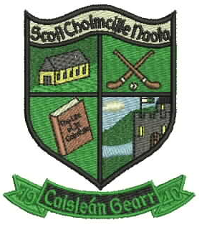
ScoilNáisiúntaCholmcilleNaofa
Castlegar

Galway

Email : castlegarns@gmail.com
Roll No. 17221K
091-757362

BOOK LIST
JUNIOR INFANTS BOOK LIST 2019
€10 book rental for use of school PM readers to be paid to class teacher in September.

English: Just Handwriting (educate.ie)
Junior Infants
Just Phonics Junior Infants (educate.ie)

Maths: Busy at Maths (CJ Fallon)
Junior Infants

Colouring Book: Rainy Days (Folens)
Junior Infants

COPIES: 2 Practise Books(32 page)
4 No. 15 Project Books (32 page)
2 large scrapbooks (NB Must be A3 in size)
2 Plastic A4 envelope Folders
2 Plastic A5 Envelope Folders
Please do not write your child’s name on their copies, this will be done in school.

EXTRA: 4 large pritt sticks
2 sets of white board marker (round top NB not chisel top)
1 set of Twistable Crayons
Please Note: No pencil case is needed for school.

NOTES:
- Lunch boxes,uniforms,slippers, coats etc. should be individually named.
- Outdoor Play: Your child will be engaging in outdoor learning throughout the year, and will be asked to bring in waterproof rain gear(Jacket and bottoms) and wellies on certain days. Please make sure they are clearly labelled.
- Schoolbags should be big enough to hold an A4 wallet folder
- Please cover books with clear plastic covers with your CHILD’S NAME WRITTEN ON THE OUTSIDE OF EACH BOOK

*€30 Materials Contribution to Class Teacher at the beginning of September to cover the following:
As with each year, we request payment of €30 towards materials for classroom use. This €30 per child is vital to help the school cover the following expenses: art materials, maths materials, science materials, and photocopying. Please send in your €30 to your child’s class teacher in a clearly labelled envelope. Please note that payment can be made in instalments if desired.
- Family Discount: one child €30, two children €50 and three children €70. This may be paid in instalments

ALL CHILDREN TO HAVE SLIPPERS OR INDOOR SHOES
PLEASE USE FOOTWEAR WITH VELCRO / SLIP ON

