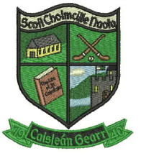

Re : Stay Safe
Stay Safe, the personal safety education programme will be taught in all classes throughout the school. The aim of Stay Safe is to teach children personal safety skills so they can look after themselves in situations which could be dangerous or upsetting. It deals initially with common situations which most children will experience at some stage or other, e.g. getting lost or being bullied. The programme also teachers children the safety skills necessary to protect themselves from physical or sexual abuse. Essentially the programme teaches children to tell a trusted adult about any problems they may have. Stay Safe and personal safety is part of the Social Personal and Health Education curriculum
It is important that parents are aware of the content of the Stay Safe lessons and are able to discuss the lessons with their children. In addition to online information, your child may bring home worksheets which will inform you on the topics being covered in class and how you can reinforce the messages at home. We have been advised that if a parent does not want their child/children included in these lessons, they will have to sign a written undertaking that they will teach them at home. This written undertaking will be put on your child’s record/file and retained for any Department of Education and Skills audit.

Opportunities will be provided through the home school links pages the children may bring home to be able to discuss the lessons with your child/children.

If you have any concerns or queries in relation to the programme, please make an appointment to see your child’s class teacher.

