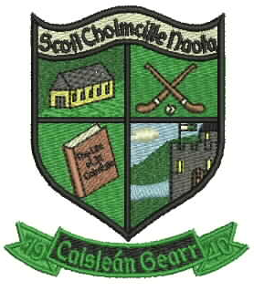
ScoilNáisiúntaCholmcilleNaofa
Castlegar

Galway

Email : castlegarns@gmail.com
Roll No. 17221K
091-757362

BOOK LIST
JUNIOR INFANTS BOOK LIST ‘18

€10 book rental for use of school PM readers to be paid to class teacher in September.

English: Just Handwriting (educate.ie)
Junior Infants
Just Phonics Junior Infants (educate.ie)

Maths: Busy at Maths (CJ Fallon)
Junior Infants

Colouring Book: Rainy Days (Folens)
Junior Infants

COPIES: 2 B2 Learn to write copies
2 No. 15 Project Books (32 page)
2 large scrapbooks (NB Must be A3 in size)
1 Junior Sum Copy (10 mm Squares)
1 Junior Sum Copy (20mm Squares)
2 Plastic A4 envelope Folders
2 Plastic A5 Envelope Folders
Please do not write your child’s name on their copies, this will be done in school.

EXTRA: 4 large pritt sticks
1 set of white board marker (round top NB not chisel top)
1 set of Twistable Crayons
Please Note: No pencil case is needed for school.
NOTES:
- Lunch boxes,uniforms,slippers, coats etc. should be individually named.
- Schoolbags should be big enough to hold an A4 wallet folder
- Please cover books with clear plastic covers with your CHILD’S NAME WRITTEN ON THE OUTSIDE OF EACH BOOK

*€30 Materials Contribution to Class Teacher at the beginning of September to cover the following:
As with each year, we request payment of €30 towards materials for classroom use. This €30 per child is vital to help the school cover the following expenses: art materials, maths materials, science materials, and photocopying. Please send in your €30 to your child’s class teacher in a clearly labelled envelope. Please note that payment can be made in instalments if desired.
- Family Discount: one child €30, two children €50 and three children €70. This may be paid in instalments

ALL CHILDREN TO HAVE SLIPPERS OR INDOOR SHOES
PLEASE USE FOOTWEAR WITH VELCRO / SLIP ON

